**SISTEMA ESCOLAR TADDEO CORDOBA**

Presentación de Vistas

1. USE `sistemaescolar_taddeocordoba`;

CREATE OR REPLACE VIEW `new_view1` AS

(select *

from alumno

where APELLIDO like '%A');

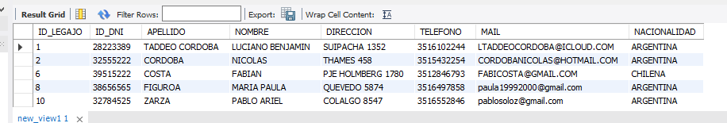

1. USE `sistemaescolar_taddeocordoba`;

CREATE OR REPLACE VIEW `new_view2` AS

(select *

from asistencia

where CODIGOTIPOASISTENCIA <> 2)

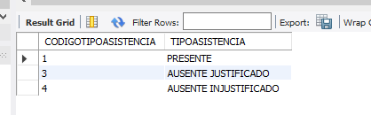

1. USE `sistemaescolar_taddeocordoba`;

CREATE OR REPLACE VIEW `new_view3` AS

(SELECT COUNT(*)

FROM asistencia_cursada

WHERE asistencia_del_alumno_alumno_ID_LEGAJO = 1

AND fecha = '*'

AND asistencia_del_alumno_asistencia_CODIGOTIPOASISTENCIA = 2)

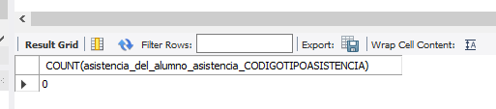

1. USE `sistemaescolar_taddeocordoba`;

CREATE OR REPLACE VIEW `new_view4` AS

(SELECT LCASE (NOMBREASIGNATURA)

FROM asignatura)

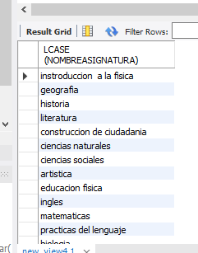

1. USE `sistemaescolar_taddeocordoba`;

CREATE OR REPLACE VIEW `new_view5` AS

(SELECT ID_LEGAJO

FROM alumno

INNER JOIN cursada

ON ID_LEGAJO = asignatura_ID_ASIGNATURA)

